KSS4 -

Functionality
During plan cost splitting, the system splits activity-independent plan costs of a cost center among the activity types of a cost center.

Scenario
In this example the labor cost of the Technology Center will be split between the activity types; R&T productive hours and R&T non productive hours based on activity quantity planning for each.

Requirements
Assignment of Cost Center to Splitting Structure R1 R&T Cost Splitting – Plan

Menu Path | Accounting → Controlling → Cost Center Accounting → Planning → Allocations → KSS4 - Splitting
Transaction Code | KSS4

1. Double Click on KSS4 - Splitting

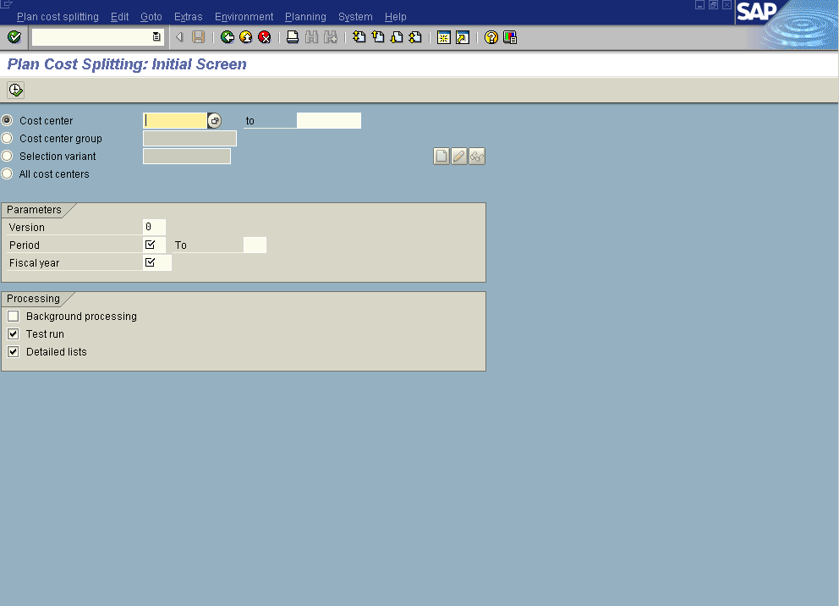

2. Firstly, check/ maintain the assignment of the splitting structure:
From the SAP main menu, use the following menu path: EnvironmentSettingsAssign splitting structure.
Splitting: Assignment of Cost Center to Splitting Structure

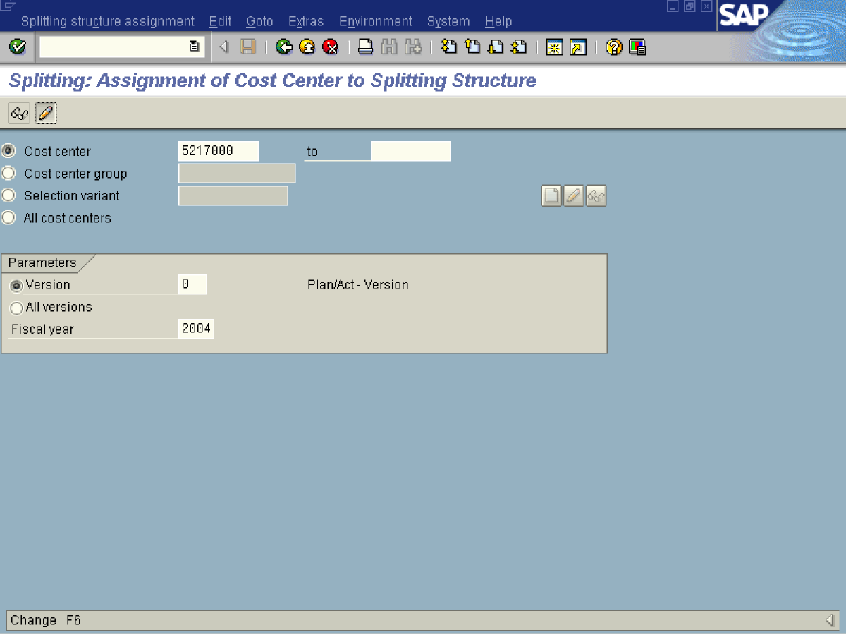

3. Click <radio button> Cost center .
4. Click <radio button> Version .
5. Update the following fields:

Field Name | Field Description | Values
Cost center | Code identifying an organizational unit to which costs are assigned | Example: 5217000
Version | Three-digit number which represents the version of the forecast parameters as defined in the forecast profile | Example: 00
Fiscal year | Calendar year. | Example: 2004
6. Click Enter to check your entries.
7. Click Change Button .

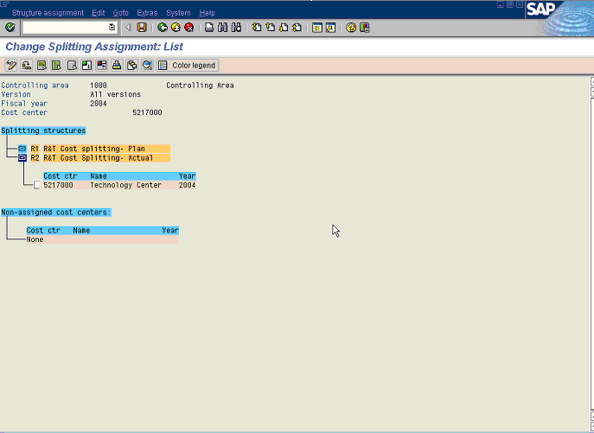

8. Change the assignment of 5217000 to the R1 Plan splitting. To do this:
- Click 5217000 Technology Center 2002 Button.
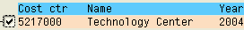
- Click R1 R&T Labor Cost Splitting Plan Button .
9. Click Move Button . Notice that cost center 5217000 is assigned to structure R1 fpr planned cost splitting.
10. Click Save button.

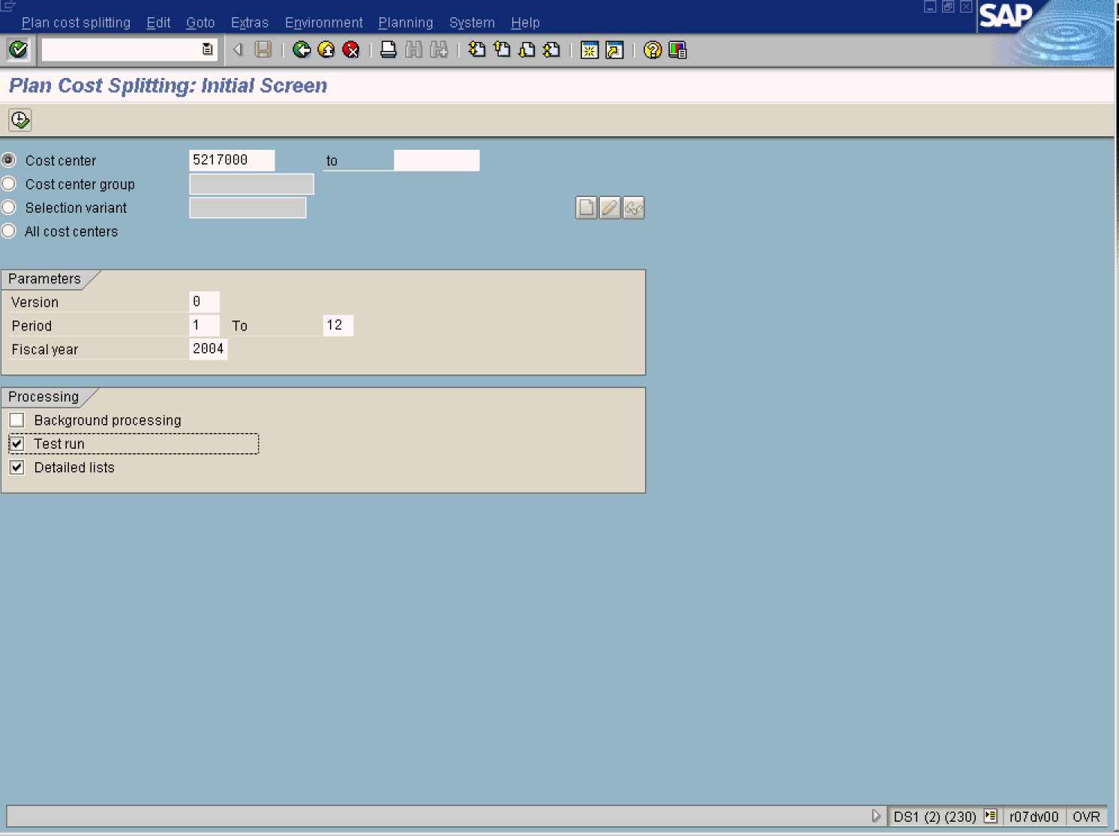
11. Update the following fields:

Field Name | Field Description | Values
Cost center | Code identifying an organizational unit to which costs or assets are assigned | Example: 5217000
Version | Three-digit number which represents the version of the forecast parameters as defined in the forecast profile | Example: 00
From Period | From period | Example: 01
To Period | To Period | Example: 12
Fiscal year | Calendar Year | Example: 2004

12. Click Execute

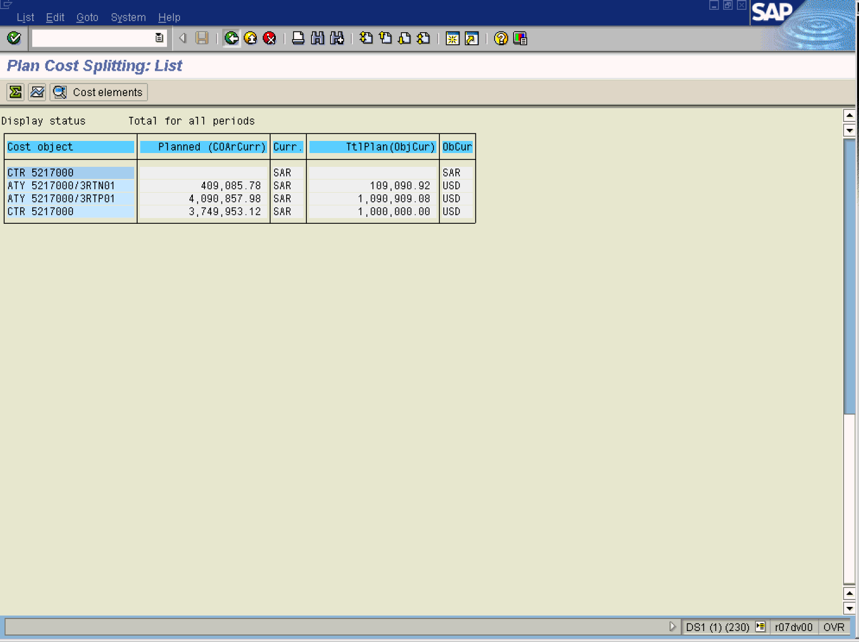

13. Click Back .

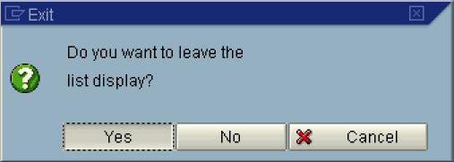

14. Click the Yes Button.

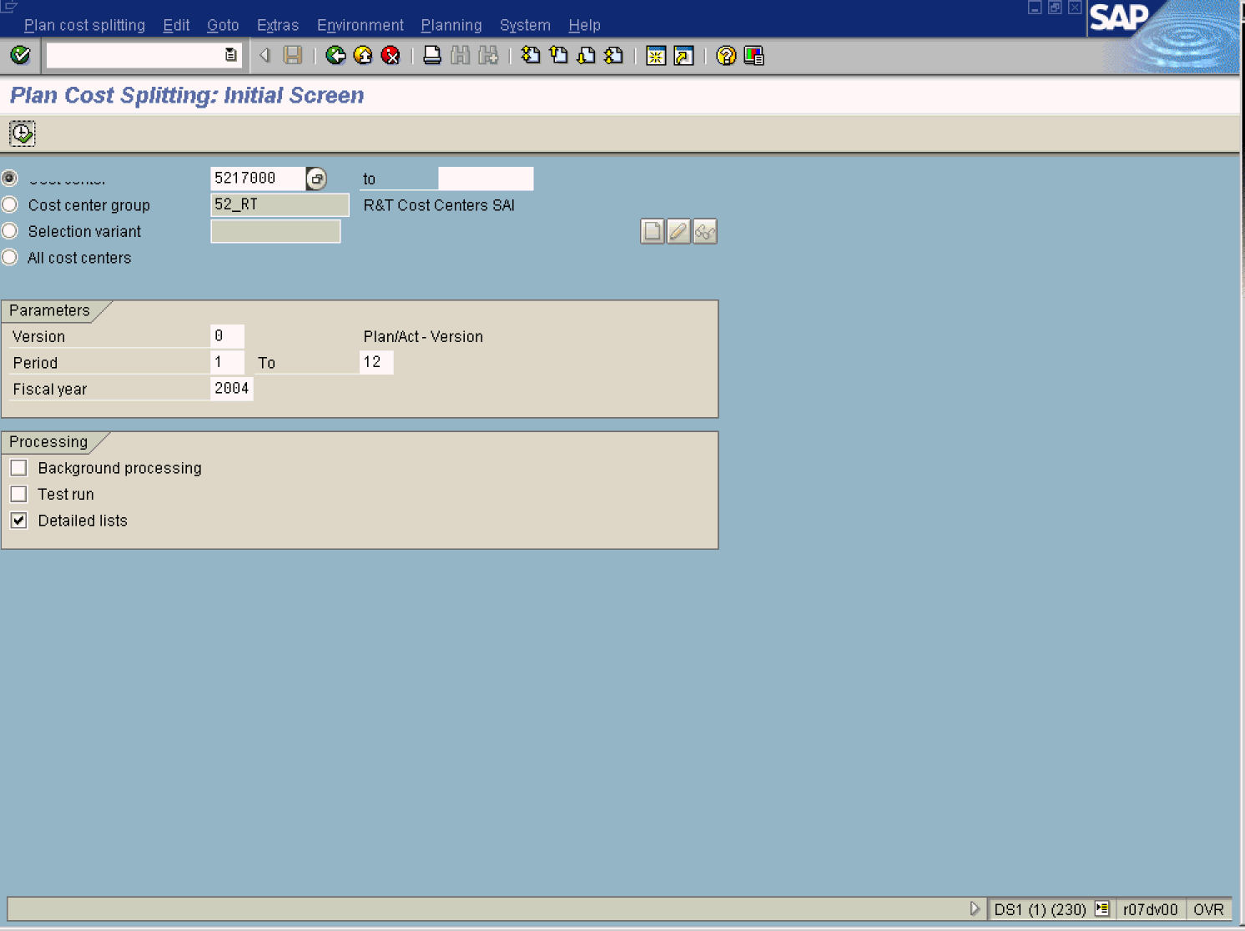

15. Click <checkbox> Test run to execute a productive run.
Note: Remove the indicator from the Test run.
16. Click Execute

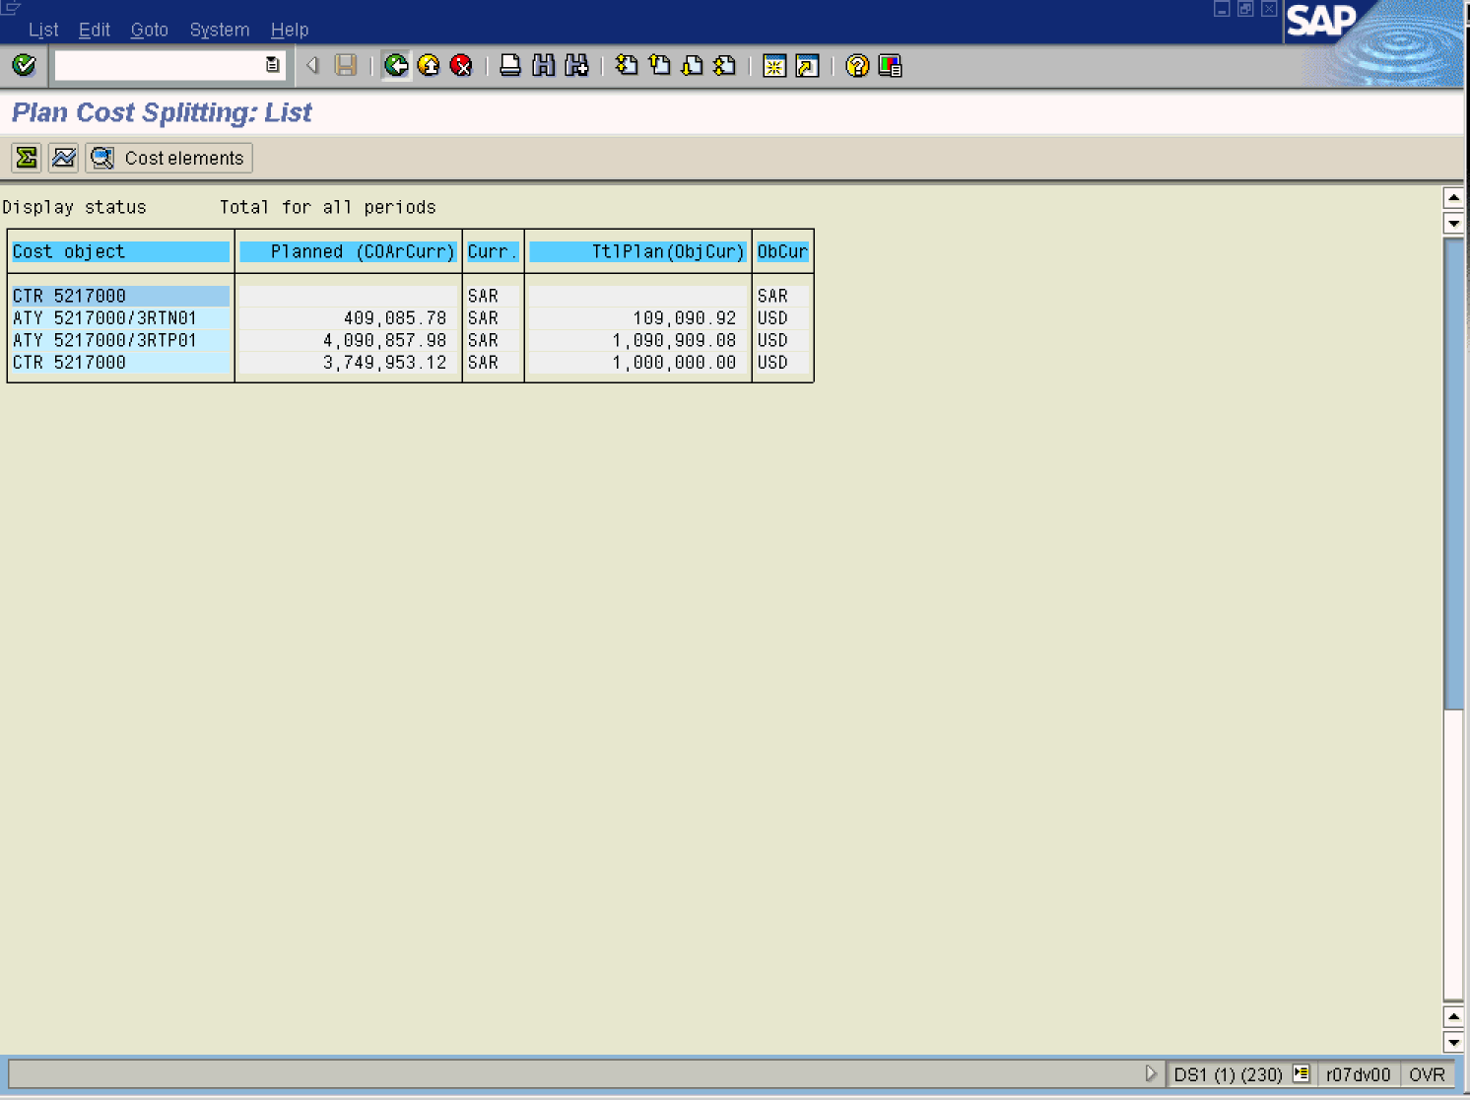

17. The system displays a detailed list of costs split for each activity allocation.
Note: Notice that the costs are split according to the quantity of productive and non productive hours planned on the cost center. In this case; 120.0 / 1,200.0

